TTMS Simplification Services
Solution Architecture Document

Version 0.1

Template Customization for Project
The following customizations to the template have been made for this document:

- New sections are added for System context view, “To-Be Deployment View” and “To-Be Security View” (Sections 6.3.4, 7 and 8)
- New section is added for ‘Technology landscape’ (Section 11)
- New section is added for ‘Foundation components’ (Section 12)
- New section Is added for ‘Integration View’ (Section 7)

Table of Contents

1. Introduction 18
The document defines the system architecture in multiple views. As-Is and To-Be views are captured as applicable. It captures the solution details of the existing project/release. 18
1.1 Purpose 18
This document should be referred first by the system engineers and software developers before digesting the content of architecture and design document. 18
1.2 Scope 18
1.3 References 19
2. Architectural Representation 19
3. Architectural Goals and Constraints 19
3.1 Architectural Goals 19
3.2 Architectural Constraints 20
4. Architecturally Significant Use-Case View 21
4.1 Request workflow Use Case View 21
4.2 Price change Use Case View 22
4.3 APS write back Use Case View 22
4.4 Announcements Use Case View 23
4.5 Calendar Use Case View 24
4.6 Dashboard Use Case View 24
4.7 Widget maintenance/customization Use Case View 25
4.8 Part registration and maintenance Use Case View 25
4.9 Price variance/gap Use Case View 26
4.10 Part substitution Use Case View 26
4.11 ‘Save as draft’ Use Case View 26
4.12 Alerts Use Case View 27
5. Architectural Solution Scenarios 27
5.1 Document Management 27
5.2 Business Workflow 27
5.3 Rules Engine 27
5.4 Desktop Integration Suite 28
5.5 NAPO Portal to WebCenter Content Integration 28
5.6 Reporting 28
5.7 Request/Workflow database 28
5.8 Data migration/Archival strategy of historical requests in Lotus Notes 29
5.9 Open requests in Lotus Notes 31
5.10 Host DB2 integration 31
5.11 Invocation of existing IMS transactions 31
5.11.1 Transactions involved 31
5.11.2 Integration pattern 32
5.12 IMS updates / APS write-back 32
5.13 Excel export 33
5.14 PDF export 33
5.15 Data loss avoidance 33
5.16 WebCenter Spaces 34
5.17 WebCenter version 34
5.18 Integration for user profile data retrieval 35
5.19 BuildFarm process 36
5.20 R1 style 36
5.21 Multiple roles 36
5.22 TBG to TESS migration - Depot code 37
5.23 Build from Scratch 37
5.24 Enhance Existing Systems 37
5.25 Buy Package Solution 37
5.26 Pros/Cons of Build/Enhance/Buy 37
5.27 Reference Architecture Determination 38
5.27.1 Complete TAG Questionnaire 38
5.27.2 Determine the Initial Application Type 38
6. Logical View 38
6.1 NAPO Applications AS-IS Architecture 38
6.2 TPNA Visual Age Application AS-IS Architecture 39
6.2.1 Visual Age AS-IS System Flow diagram 41
6.3 NAPO Portal Architecture 42
6.3.1 As-Is 42
6.3.2 To-Be Conceptual View 44
Conceptual view of NAPO Portal phase II is shared below. 44
6.3.3 To-Be Logical View 45
6.3.4 To-Be System Context View 49
System Context view for NAPO Portal phase II is shared below. 49
7. Integration View 49
8. To-Be Deployment View 50
9. To-Be Security View 52
9.1 AMS Portal UI Security 54
9.2 WebCenter Content (WCC) Security 54
9.3 WebCenter Portal to jBPM security 54
10. Process View 54
11. Implementation View 55
11.1 Overview 55
11.2 Customize the chosen TAG NA SDM if Needed 55
11.3 Layers 55
12. Technology landscape 55
13. Foundation Components 56
14. Service Allocation to Components 57
SPIS 57
General Part /YPL101 57
Technical Part/YPL100 57
Stock Status/YPL102 57
Order Status/YPL103 57
Leverages ICE web service “ProcessPartInformation” hosted in ESB 57
14.1 Service Realization Related Architectural Decisions 57
15. Architectural Risks and Impact 57
15.1 Financial Impact and Risks 57
15.2 Potential Business Impact 57
15.3 Potential System Impact and Risks 58
15.3.1 Assumptions and Constraints 58
15.3.2 Dependencies 58
15.3.3 Performance Analysis 58
15.3.4 Environment Analysis 58

- Introduction

The Solution Architecture is owned by the project architect. It is created in collaboration with enterprise architects and other project stakeholders involved in making architectural and technology decisions.
The document defines the system architecture in multiple views. As-Is and To-Be views are captured as applicable. It captures the solution details of the existing project/release.
  - Purpose
The Solution Architecture Document has multiple audiences. These include enterprise architects, technical architects, designers, system engineers, developers, project managers etc.
This document provides the exhaustive architectural overview of the system in the form of different architecture views. It also captures the key architecture decisions taken in defining the system architecture, along with the details of various solution options considered. The merits and demerits of each solution option considered are documented along with the rationale for the solution. To gain complete understanding of the system architecture, this document has to be studied along with business process models/requirements specifications and the use case specifications.

This document should be referred first by the system engineers and software developers before digesting the content of architecture and design document.
  - Scope
The scope of the Solution Architecture Document for the TTMS simplification project provides details describing the architectural overview of the project, the goals and the guiding principles, architecturally significant requirements, solution scenarios, architecture views including logical, security, deployment etc., This document will address technical feasibility and capture multiple high level technical options that are called “solution scenarios.” This document evolves as the solution scenarios transform into candidate architecture, and finally solidify into solution architecture. This is a living document that needs to be updated through the evolution journey till end of the Elaboration phase. This will be revisited (if required) during the construction phase to make any minor modifications as appropriate.
This document is updated for TTMS simplification to define the architecture views for TTMS simplified system. This document will be updated iteratively on an ongoing basis for subsequent releases to make sure that the latest TTMS simplified system SAD is always reflecting the complete As-is solution architecture of TTMS suite of projects.
This document will be base-lined and signed off at the end of Elaboration phase. Any subsequent changes [if required] during the Construction phase will be routed again for approval.
  - Background
Toyota Transport Management system (TTMS) is used by The Toyota Motor Sales (“TMS/USA”) for routing vehicles from VDCs (Ports & Marshaling Yards) to the final dealer to whom the vehicles are assigned and to manage the invoice for vehicle shipments. TTMS creates shipment plan for transporting the finished vehicles from VDC to the final dealer.
TTMS assigns the route and the rate for each shipment order based on the pre-defined business rules. TTMS handles the processing and inspection operations that are carried out during the actual shipment process.
It tracks the shipment events and creates invoices and transmits the invoice to PeopleSoft for final invoice to Carriers & Service providers...”

The current TTMS OTM COTS product will be replaced with ICL SaaS solution due to the following key constraints are identified.
- OTM was not designed for finished vehicle logistics, resulting in technical and manual workarounds that impact TLS’s ability to meet business requirement.
- Difficult and expensive to maintain due to system integration complexity periodic, resource intensive upgrades.
- Requires resources high priority initiatives(e.g. N.A Export, Transportation Claims automation, etc. to support OTM)
- In-house technical workarounds to meet business needs (e.g. Preliminary tender, Governor and Sequencing ...etc.)
- Time consuming manual workarounds in place(e.g. Manual re-planning, fictitious routes/carriers, operational delays/disruptions)
  - References
- Blueprint Website
- Toyota Reference Architecture Website (http://tv/tra)
- TTMS simplification system Supplementary Specifications
- TTMS simplification system business use cases

- Architectural Representation
There are many different architecture views available for documentation. Following are the different views of the software architecture that will be covered in this document:

# | View | Audience | Area | Purpose
1 | System Context | All | Conceptual understanding of the system and its boundaries | Documents how the system interacts with external entities (systems and end users) in abstract sense [Black box representation]
2 | Logical (Solution) | Designers | Requirements realization | Documents the various layers and components involved in the solution, along with information flow
3 | Implementation | Programmers | Software components | Describes the overall structure of the implementation model and decomposition of the system into code and data artifacts
4 | Deployment | Deployment Leads, Programmers | Physical nodes | Documents the mapping of runtime components/binaries to the computing nodes [OS, Hardware]
5 | Security | Designers, Programmers,  Deployment Leads  Data Administrators | Authentication, Authorization | Documents the security solution applicable to different application tiers and components [Covers solution at all levels including transport, network etc.,]

- Architectural Goals and Constraints
  - Architectural Goals

- To enable high degree of ‘ease of use’
- To build a platform that responds to business changes quickly
- To maximize business benefits
- To build a standard platform that is interoperable with existing data and application/technology components [TTMS and other system components]
- To build a scalable and extensible platform
- To leverage industry standard best practices that includes effective use of appropriate design patterns
- To build a secure platform that enables data to be accessed only by authorized users in a timely manner
- To enable flexibility in critical areas to meet ongoing improvements and business changes
- To maximize reuse of the existing and new components to be built
- To minimize the duplication and replication factors
- To minimize the technological/platform diversity factor
- To minimize the customization for relatively quick product upgrade and improved maintenance levels
- To maximize tools use
- To build a loosely coupled solution with high degree of extensibility and maintainability
- The Business partner will be required to comply with TMS integration and security patterns.

There could be cases where conflicting goals and/or requirements have to be dealt with. The decision will be taken on a case-by-case basis in accordance with the priority of goals/requirements agreed with the project stakeholders. Any such conflicting technical decisions will be documented with a rationale.
  - Architectural Constraints

- The solution architecture should adhere to guiding principles of the Toyota Reference Architecture (TRA)
- The solution architecture should adhere to the enterprise security and integration standards
- The solution architecture must leverage the enterprise security solution “TESS” (Toyota Enterprise Security Services) for authentication needs.
- The technology choice/recommendation should align with the enterprise guidelines/roadmap where applicable
- The application architecture and design should leverage the existing technology stack in place for TTMS
- The solution architecture is adhere to minimize or not to impact the downstream components
- The solution architecture extends the existing architecture due to scope of limited changes on the downstream components.
- The solution architecture is defined the scope of changes to the TTMS boundary.

- System Context

The system context represents the entire system as a single object or process and identifies the interfaces between the system and external entities. Shown as a diagram, this representation defines the system and identifies the information and control flows that cross the system boundary.
- The system context highlights important characteristics of the system:
- Users, external systems, batch inputs and outputs, and external devices
- External events to which the system must respond
- Events that the system generates which affects external entities
- Data that the system receives from the outside world which must be processed in some way
- Data produced by the system and sent to the outside world

  - System Context Diagram As Is

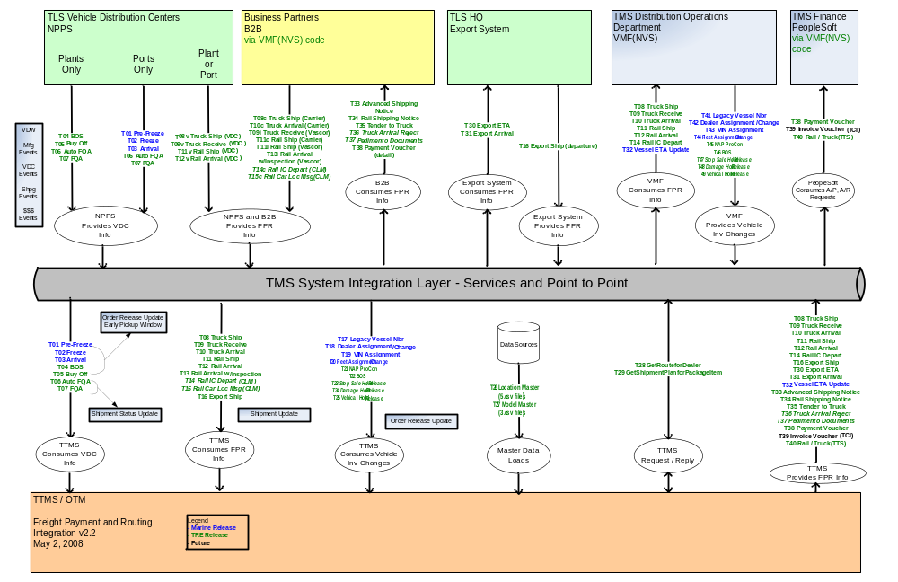
  - System Context Diagram To Be

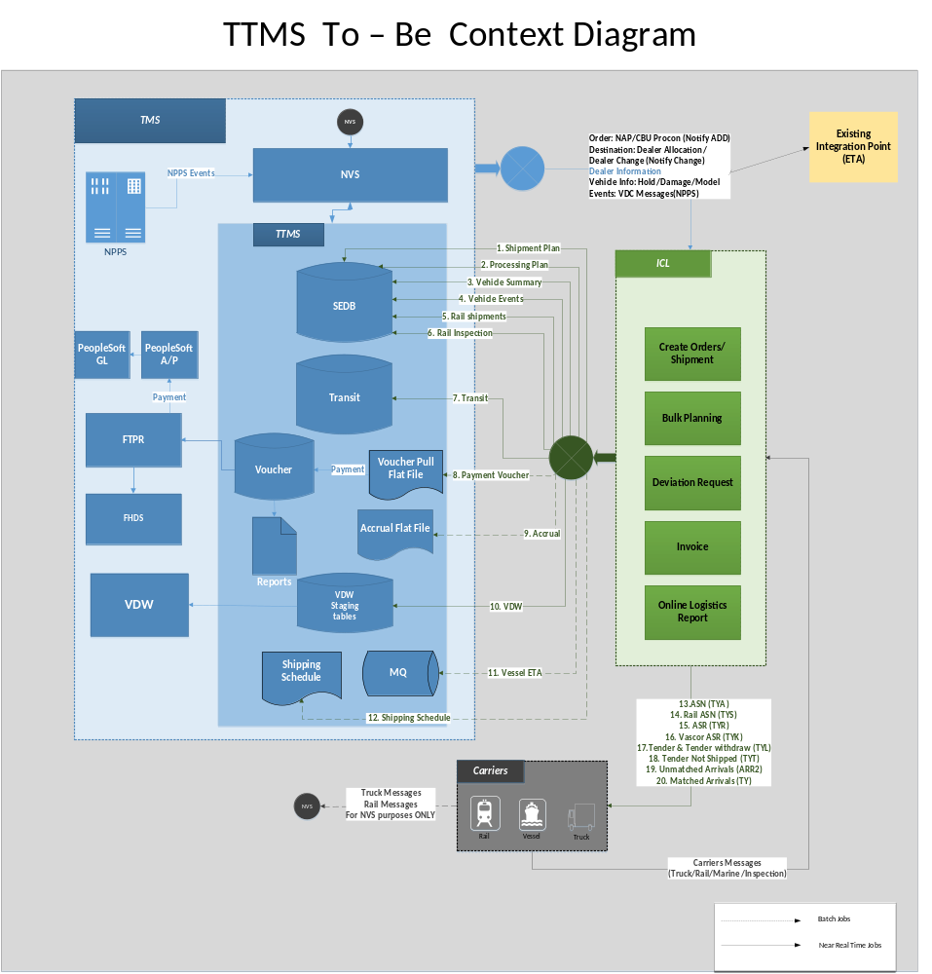
  - Interacting Systems & External Data Store

ICL
Description | TTMS interface with ICL for inbound and outbound operations as a web service for Creation of Shipment Plan, Manage Shipment related Events, and Manage Shipment related invoice, Manage Deviation Requests.
Type | System
Owners | ICL

NVS
Description
Type | System
Owners | ICL

NPPS
Description | NPPS system is used at the Vehicle Distribution Centers (VDC) and Vehicle Distribution office (VDO) to do the post production activities including buyoff, PQA, FQA and shipment of vehicles to the dealers .NPPS sends the message to TTMS for BDY, PNT, ASM BUY, AQA, FPR , TS1, RSC, RR1, RC1
Type | System
Owners | TMS

VDW
Description | VDW pulls the Logistics related information from TTMS system through TTMS database. VDW has a Freight data mart used by TLS users which provides information like Shipment, Invoice, Service provider, Location, Vehicles associated with Shipment etc. To populate the Freight data mart, VDW pulls data on a daily basis from TTMS system.
Type | System
Owners | TMS

FTPR
Description | FTPR is the Freight Payment Routing System and interface with TTMS. TTMS sends the Payment information to FTPR
Type | System
Owners | TMS

FHDS
Description | H
Type | System
Owners | TMS

- Architecturally Significant Use-Case View

Below are the criteria to identify architecturally significant Use cases.
- Memory intensive operations
- High performance expectations
- Asynchronous operations
- Scheduled jobs\ Batch processing
- High availability
- Security

- Architectural Solution Scenarios
  - TTMS Replacement Vs Outsource to ASP Vendor
  - Real Time Integration Vs Batch Mode Integration

ICL- TTMS Batch Feed Integration (TBD)
  - Message Exchange Patterns

The new TTMS B2B Integration is being considered with message communication patterns with 3 options. The objective of the solution to design the reliable message system with loosely coupled plain web service interfaces.

Message Communication and Acknowledgement Pattern

TTMS inbound Integration is considered with 3 options. The objective of the solution to design the reliable message system with loosely coupled plain web service interface.

Option1: Two-way Synchronous Communication: The client uses exposed service to achieve synchronous communication and receive a response immediately. Upon receiving the request, the server starts processing it while holding the connection with the client open until a response (or an error) is ready to be returned to the client on the open connection. The request can be initiated from both the end (ICL && TTMS) at both the ways from either ICL or from TTMS.

The following diagram explains the sample synchronous communication with one way from ICL to TTMS, The same flow in other way around is being considered to include the option 1 as two way synchronous communication pattern.

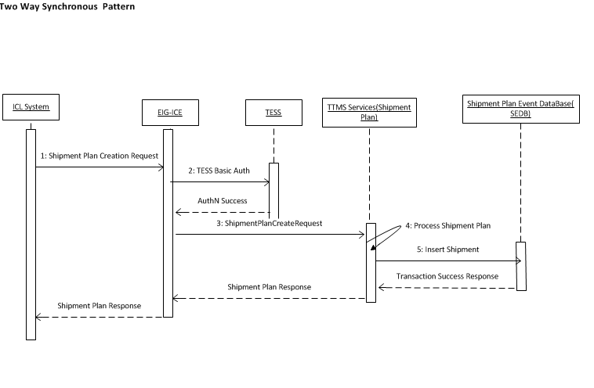

Step 1: The Shipment Plan request is initiated from ICL
Step 2: EIG validates the request headers and authenticate with TESS
Step 2.a: TESS sends the success acknowledgement
Step 3: EIG forward the request to TTMS back end Web Services
Step 4: TTMS performs the business validations and calls the SEDB insert

Step 5: The Shipment Plan is created in SEDB and the success Transaction response sent to ICL

Note: The entire flow is continued as sequential flow and each of the component will wait until the response served with in the request timeout defined in each of the layer.

Option 2: Two-Way Asynchronous Communication: Two-way asynchronous communication in this document context, when the request is initiated from the client (ICL) then the Provider (TTMS) receives the request and dispatch the request in different new process or container (Queue/Data Store) then sends the successful transport acknowledgement of receiving the message. This case the actual business process may not be completed even though the successful transport acknowledgment is being delivered to the consumer.

The new process will be initiated to complete business transaction and then sends the successful business transaction acknowledgement. The acknowledgment can be either through web service or any notification mechanism. The communication can be initiated from both the ICL and TTMS vice versa.

The following diagram explains the flow of two way asynchronous pattern but the diagram is drawn for the one-way from ICL to TTMS and the same way the communication will be followed from TTMS to ICL during outbound integration.

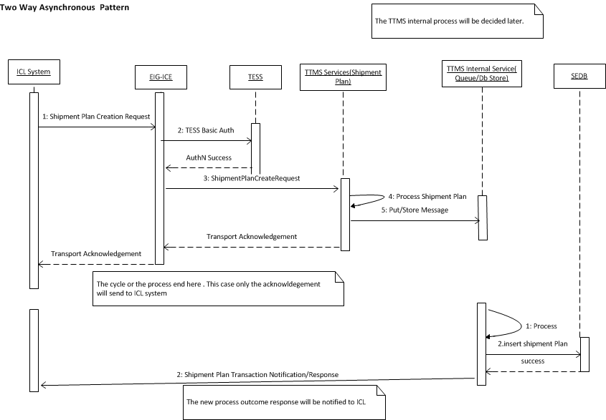

Step 1: The Shipment Plan request is initiated from ICL
Step 2: EIG validates the request headers and authenticate with TESS
Step 2.a: TESS sends the success acknowledgement
Step 3: EIG forward the request to TTMS back end Web Services
Step 4: TTMS performs mandatory message attributes validations
Step 5: TTMS puts the message into TTMS internal service (Queue/DB Store)
Step 6: TTMS services sends back the acknowledgement to ICL back to all the layer to ICL

Step 1: The new process queued or initiated
Step 2: TTMS inserts the shipment plan in SEDB table
Step 3: Sends the actual success/failure business transaction confirmation/notification to ICL with different interface

Option3: Mix of option1 and option3. There are few plain CRUID service interface may not be needed to process as asynchronous where the time of completion request is almost equal to the process of dispatching the request. This provides the advantage of consumer to know the actual state of transaction rather than assuming as successful transaction and sending subsequent requests even though during the previous request business failure scenarios.

Solution options | Pros | Cons
1.Two-Way Synchronous Communication | - Provides the clear end to end single span of request and response flow.  - The business transaction acknowledgement will be received by consumer on the same request initiated.  - Avoids consumer not to send the invalid messages to TTMS since the previous response has the successful transaction completion acknowledgment status to decide the business flow.  - Sequence and business failure will be controlled in default in nature sudden extend from consumer end. | - Holds the request until the backend completes the transaction.  - Will advisable only light volume transactions.  - The acknowledgment may not be sent to consumer even though back end successfully completed the transaction during timeout issues.
2.Two-Way Asynchronous Communication | - Meets ‘Single responsibility’ principle(Low coupling)  - The transport layer acknowledgement will be given to consumer in order to process the next events.  - Faster response time to consumer | Increase the business coupling on TTMS layer where consumer did not operate the next event based on the previous web service business transaction sent to TTMS.  TTMS need to build another asynchronous flow after transport layer acknowledgement which introduce additional technical complexity.
Mix of Option1 & Option3 | - Attains the benefit of option1 and option2 | Still have the problem of timeout but most of the industry models even mid volume transaction is following the synchronous response for instant response mandate transactions.  This Option may not work completely when we decide to use the global queue sequence mechanism placed. By default the Asynchronous design takes place and leads to use the option2.

Message Structure and Acknowledgement Format – To be updated

The high level message format for different categories are mentioned in the ICE message document. The reference path will be given later.

SOAP Web Services Vs Restful Web services

The SOAP and Rest web services are considered as the options.
Solution options | Pros | Cons
SOAP | - SOAP use WSDL to define the clear contract design between the provider and consumer.  - SOAP supports other protocols SMTP,FTP,etc other than HTTP  - SOAP supports message level security encryption  - Development and tools support  - Build in error handling and retry mechanism  - Supports MTOM file compression techniques  - XML offers the options for transforming different structure, or format of the data along with actual data but JSON does support only with traditional message format. | - SOAP does not support multiple message format.  - Makes tightly coupled with systems together  - Increases the maintenance Cost due to simple change makes the revision of contract and implementation changes on both the end.  - Slower performance than REST due to the heavy object binding and marshalling process.
REST | - REST is more dynamic, no need for creating and updating UDDI.  - REST is not restricted to XML format. REST web services can send plain text, JSON, and also XML.  - REST is much more lightweight than SOAP  - REST is providing better performance than SOAP | - Supports only over HTTP  - REST does not support WSDL but supports WADL but does not have the standards compared to SOAP WSDL.  - REST does not support message transformation.  - REST does not support the default error message and Retry handling as SOAP is having in built support  - REST does not support file compression MTOM compared with SOAP  - REST does not support message level encryption and the encryption can only be achieved in Transport layer.

Message Sequencing

Message Error handling and Recovery Process

- Architectural Decision Logs
The details of various solution options considered, along with qualitative [Pros & Cons] analysis are included in Appendix.
  - Web Service Pattern
Subject Area | Web Service Pattern |  | Topic |  | Rest/JSON Vs SOAP/XML
Issue or Problem Statement |  | The web service pattern need to be identified either SOAP/XML or Rest/JSON based web service pattern.
Related Use Case / Requirements |  | Technical Use case
Solution[s] |  | The solution is identified as two options  Rest with JSON  SOAP with XML
Decision |  | The decision is to use Rest Architectural style.  The decision is to use JSON Message format.
Rationale |  | The limitation of Rest is at the message level security where SOAP provides as a default but as per EISP categorization, the 2way SSL with Basic authentication accommodates the EISP security guidelines for confidential data classification.  XML offers the options for transforming different structure, or format of the data along with actual data but JSON does support only with traditional message format.
Assumptions |  | The JSON message structure validation will happen at the EIG side.  JSON supports to send the flat file with traditional formats.
Justification |  | Refer the Pros section of Rest and Cons section of SOAP mentioned in the solution scenario “Rest Vs SOAP”.  The below are the justification points to use JSON  - JSON parsing is generally faster than XML parsing  - JSON is a more compact format, meaning it weighs far less on the wire than the more verbose XML.  - Formatted JSON is generally easier to read than formatted XML.  - JSON specifies how to represent complex datatypes, there is no single best way to represent a data structure in XML.
Implications |  | - The Retry mechanism need to be handled on the consumer side  - The message level security cannot be achieved in Rest based pattern, In future the system demands then need to revisit the pattern or wait Rest has to emerge with message level security.
Derived requirements |  | - Retry Mechanism need to be implemented across the layers  - Application has to build the error handling mechanism and mandatory field’s validations on the application layer.

  - Message Communication and Acknowledgment Pattern
Subject Area | Message Communication Pattern |  | Topic | Two Way Synchronous Communication | Two Way Asynchronous Communication
Issue or Problem Statement |  | Decide the message communication to use synchronous or asynchronous pattern
Related Use Case / Requirements |  | All the inbound and Outbound interfaces.
Solution[s] |  | The solution is identified as two options  - Two way Synchronous Pattern  - Two way asynchronous Pattern  - Mix of synchronous and Asynchronous Pattern
Decision |  | The decision is to use Option 2(Two Way Asynchronous Communication) due to the advantage not holding the connection to complete the entire transaction with stateless communication.
Rationale |  | The limitation of Option 2 (Two Way Asynchronous Communication) will increase the business validations scope in TTMS boundary and the nature of sequence will be removed when ICL sends the next events by assuming the previous events are succeeded but some cases the transaction may fail in TTMS and will make the continued failure of events will lead into manual intervention and error recovery process.
Assumptions |  | ICL sends the messages in built sequence and if any sequence based errors will be handled through error handling process.(Please refer the error handling scenario mentioned ...(To be Updated)
Justification |  | - Faster Response time  - Loosely Coupled business transaction Processing.  Please refer the section 6.2.1 Option2 for more details.
Implications |  | Sometimes the business transaction is almost equal to the transport acknowledgement time where it increases the additional increase of storage that leads to additional store and process design consideration.
Derived requirements |  | Derives the technical requirement to add the new storage of queue or Database to hold and process the message to make the asynchronous communication.

  - TTMS Outbound Integration with Downstream Systems
  - TTMS inbound & Outbound Message Sequencing

- Logical View
This section will describe the Logical architecture of As-Is and To-Be views for TTMS application.

  - TTMS Applications AS-IS Architecture
The following diagram explains the as-is representation of existing TTMS applications and their system interaction.

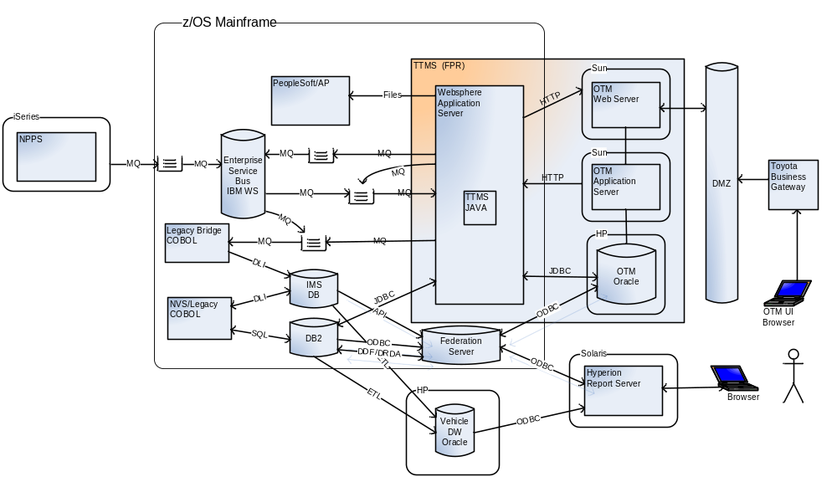

To-Be Conceptual View

Conceptual view of TTMS application is shared below.

To-Be Logical View

The layered view of TTMS shared below.

- The core design principles including separation of concerns, dependency injection, loose coupling and encapsulation will be adhered.
- The design patterns will be leveraged to reduce coupling, improve abstraction and increase reusability.

Application Layer

Common Components

Data Layer

Security Layer

Integration Layer

Enterprise Services

- Integration View

  - Internet-Facing B2B Integration(ICL-TTMS)

TTMS simplified web services follows the B2B Integration pattern. ICL and TTMS shares the business information in order to perform the logistics operations. ICL is an ASP providing the software as service in order to perform current TTMS logistics operations.

The following diagram depicts the layering view of general TMS B2B Integration view.

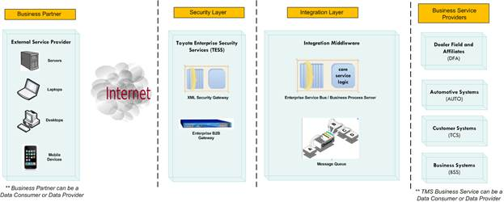

ICL will provide the software and service for TTMS Freight Planning and the Invoice Operations that includes Managing Truck, Rail & Vessel Rates, Manage Processing and Inspection Charges (Master Data management), Creation of Shipment Plan, Manage Shipment related Events, and Manage Shipment related invoice, Manage Deviation Requests, Report Generation and Data Propagation. ICL, a finished vehicle specific SaaS solution, best aligned with our current and future business needs.

The integration with ICL with TTMS simplification has been split into two parts. The inbound integration describes the communication start from ICL to TTMS simplified web service application. The outbound integration pattern describes the communication start from TTMS simplified web service application to ICL.

Integration Patterns
- EIG is the security gateway between TTMS (TMS) and ICL for both Inbound and Outbound Integration. EIG is the primary point of interface between ICL and TTMS web service system.
- The TESS service authentication handled at the EIG layer for the each service request sent by ICL.
- TMS had adopted support of RESTful services pattern over HTTP.
- Two way asynchronous communication pattern to exchange the messages between TTMS and ICL(Refer Section 6.2)
- XML and JSON payload formats are supported in TMS standard but the JSON is being considered to use as message format due to the advantage of smaller message size, compact and other advantage factors. Please refer the Architectural decision log that explains the decision over Rest/JSON pattern.

Web Service Integration Design Principles

The TTMS web services will follow the web service design principles and guidelines.
Description | Principles and Explanation
Service Loose Coupling | The principle of Service Loose Coupling promotes the independent design and evolution of a service’s logic and implementation while still guaranteeing baseline interoperability with consumers that have come to rely on the service’s capabilities.
Service Abstraction | This principle emphasizes the need to hide as much of the underlying details of a service as possible, Service Abstraction also plays a significant role in the positioning and design of service compositions.
Service Reusability | The principle of Service Reusability emphasizes the positioning of services as enterprise resources with agnostic functional contexts. Numerous design considerations are raised to ensure that individual service capabilities are appropriately defined in relation to an agnostic service context, and to guarantee that they can facilitate the necessary reuse requirements.
Service Autonomy | The principle of Service Autonomy supports the extent to which other design principles can be effectively realized in real world production environments by fostering design characteristics that increase a service’s reliability and behavioral predictability.
Service Statelessness | The management of excessive state information can compromise the availability of a service and undermine its scalability potential.

ICL-TTMS Inbound Integration

The following diagram explains the inbound integration (ICL → TTMS) with detailed steps. The request is initiated from ICL and the business response will be provided by TTMS system.

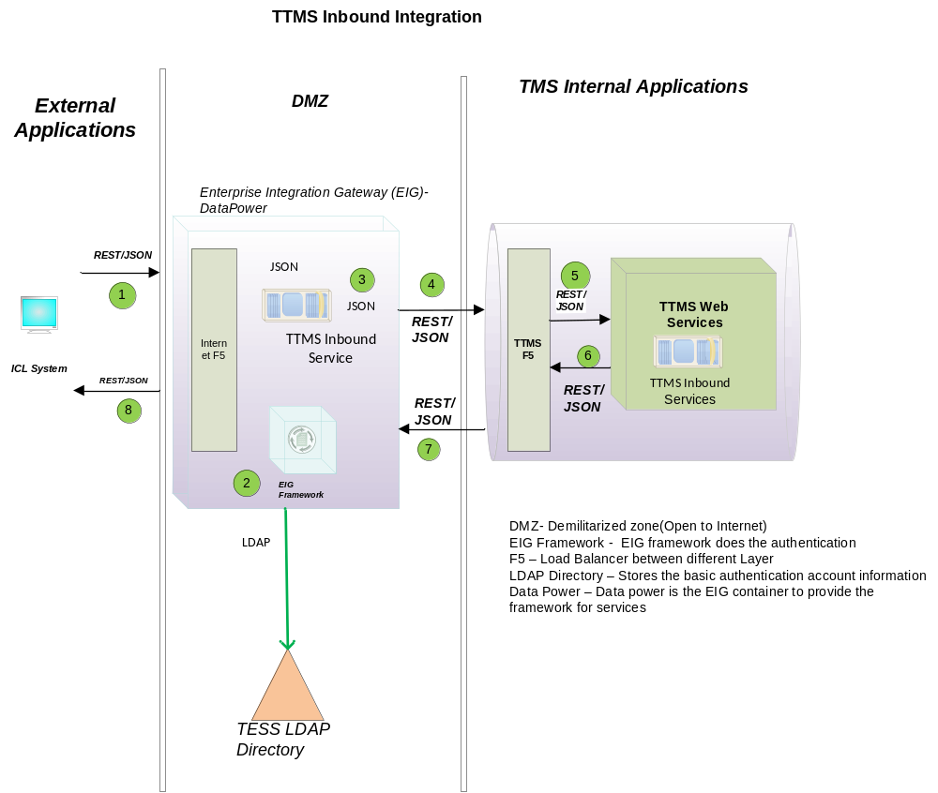

1) ICL application sends the request in REST/JSON Format
2) EIG Authenticate the request against TESS to validate the service account credentials.
3) EIG validates the message format
4) EIG sends input request to TTMS Inbound services through TTMS F5.
5) TTMS Inbound Services receives the request in (REST/JSON) format and serves the request.
6) EIG getting response/acknowledgment back from TTMS Inbound back end services.
7) EIG send the response/acknowledgement back to ICL.

Note: This is high-level integration flow and the process starting from TTMS web services will be explained later with continued pattern . Ref : ----------

ICL-TTMS Inbound Integration Services

The list of inbound services are identified listed down in the table. The table indicates the business requirement of As Is and to be process frequency. All the batch process will be converted to real time or near real time process. The

TTMS-ICL Outbound Integration

The following diagram explains the TTMS outbound integration (TTMS → ICL) with detailed steps. The exactly same pattern of flow will happen in outbound integration in the other way route where the request is initiated from TTMS and will be served by ICL.

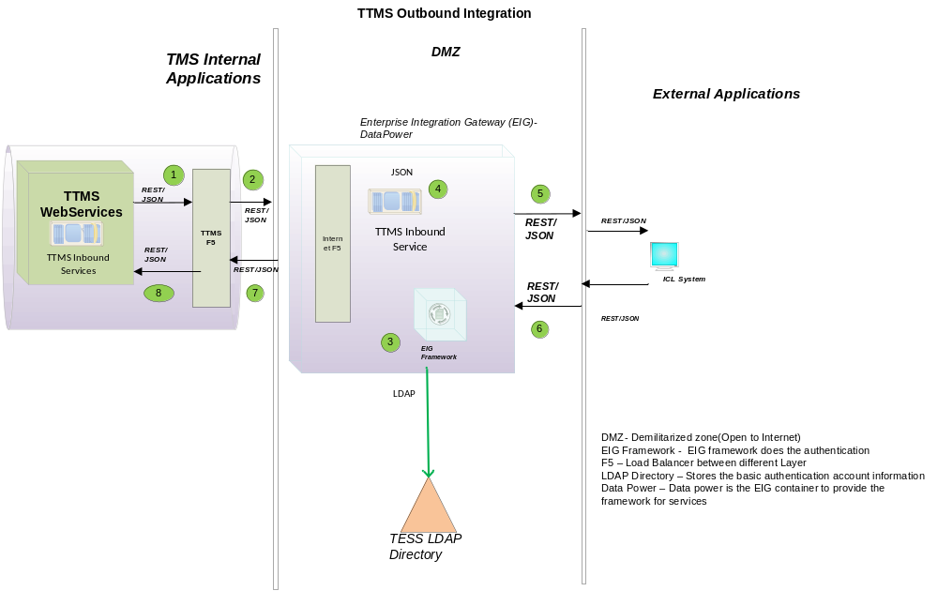

- TTMS application sends the request in REST/JSON Format to F5
- TTMS F5 delegates the request to EIG
- EIG Framework Authenticate the request against TESS to validate the service account credentials
- On the result of successful authentication, EIG validates the message format.
- EIG sends the request to ICL Web service using Rest/JSON format
- ICL receives the request and process the message.
- ICL sends the transport acknowledgment/business response to EIG with Rest/JSON pattern.
- TTMS receives the transport acknowledgement or business response and process internally.
  - Security Integration

TTMS –EIG -ICL Services Security Integration

TTMS ICL services security integration is considered mutual SSL with 2 factor authentication.

Mutual SSL (2-way)

Basic Authentication (Service Account Validation)

Mutual SSL authentication will be established between ICL and EIG, The direct SSL communication happen from ICL to EIG layer and vice versa.

The Basic authentication will be done at the EIG layer for both the inbound and outbound integration. ICL service account will be validated during inbound web service communication. The same way TTMS service account will be validated against in TESS during outbound communication.
  - TTMS Internal Integration Patterns

TTMS MQ Integration
The new TTMS system uses existing MQ integration as the same way it was integrated right now but due to the new application domain creation the existing MQ integration will be created using MQ provider supported by JBOSS. The technical solution decision for MQ and associated technologies options will be explained in detail in the “Message Sequencing” section.

Host DB2 Integration
TTMS system uses all the DB2 communication through the back end layer. The following scenarios are making the mandate of DB2 integration. All the tables listed down here except few already part of existing system. The new “To Be” application will use same tables as same way of read and write operations performed by current system.

Interface Name | Purpose | Tables Used | New/Existing Table
Shipment Plan Service | Shipment Planning information (route) | TTMS Shipment Plan | Existing
Processing Plan | Processing plan information | TTMS_PROCESS_PLAN | Existing
Vehicle Events | AQA, FQA, Buy-Off | TTMS_VEHICLE_EVENTS | Existing
Vehicle Summary | Vehicle information | TTMS_VEH_SHIP_SUMM | Existing
Rail Shipments | Shipment by Rail Carrier | TTMS_RAIL_EVENTS, TTMS_RAIL_VEHICLE | Existing
Rail Inspection | Vehicle inspection at Rail Head | TTMS_RAIL_EVENTS, TTMS_RAIL_VEHICLE | Existing
Transit | Transit Leg information | VEHICLE- MASTER_TRANSIT  VEHICLE - TRANSIT_LEG -  VEHICLE - TRANSIT_LEG_SEQ  VEHICLE- TRANSIT | Existing
Voucher | Payment voucher to carrier for shipping the vehicles | TTMS_VOUCHER, TTMS_VOUCHER_VINS | Existing
Accrual | Report | It’s a report. Not stored in table. | Existing Report
VDW | Vehicle Date Warehouse | New tables will be created in TTMS | New - TBD
Vessel ETA | Vessel ETA information | Vessel ETA data will be loaded into VEHNVS.VESSELETA.PROCESS and consumed by VJ02DX | Existing
Shipping Schedule | Shipment schedule information. | Marine shipping report data are received as flat file from Hyperion. Below are the details where Hyperion stores the data and sample. | Existing

  - TTMS Systems Integration

VDW Integration

Vessel ETA Integration

TOMS Integration

Vascor Integration

NVS Integration

FTPR Integration

FHDS Integration

TTMS Audit Integration

TMS Redwood Job Integration - TBD

TMS NAS Share Integration - TBD

  - DevOps/IT Ops Integration

Fog Light Integration
The Quest Fog light will be used for application monitoring; it also provides application server health check and performance monitoring. The Fog light integration solution is adopted as part of TMS enterprise service solution.

Build Farm Integration
To align with the enterprise strategy, Maven repository will be built for TTMS simplification. Also as part of TTMS simplification (Plain vanilla JEE) applications to the new infrastructure is planned. The build and deployment will be done thorough build farm agents through build farm servers. As part build management process a new stream will be created with Sonar integration to analysis the code quality.

Jboss App Framework Integration

TMS established technology direction is on “Distributed” platform and using the Java Enterprise Edition (JEE) software programming language.
TMS has adopted the Spring Framework 4.x software technology stack as the foundation for all custom application development. App framework had developed the framework subset components for framework assembling, layering configurations with reusable components. TTMS Simplification will adopt the framework components and follows the guidelines suggested by App framework

- To-Be Deployment View

- To-Be Security View

  - ICL-TESS SSO Integration

As part of ICL SaaS software as a solution to TLS business, TLS users are needed to login and perform the key business operations in the ICL portal as mentioned in the section “Service Integration with ICL” section. SAML 2.0 protocol will be leveraged to facilitate this functionality.

The TESS federation solution will improve user experience by seamlessly allowing users to transition across domains using SSO and single-sign-off. TMS will act as both an SP for external users to utilize TMS’s resources and as an IDP to federate internal users to use services in other affiliate domains. This federation service will enable users to authenticate and use authorized resources without the need to enter application credentials multiple times. User identity will be federated, and sessions will be managed to enable single sign on and single sign off across realms. There are 2 patterns are applicable to implement the SSO federation solution as described below sections.

The recommendation is to use SP initiated identity federation over HTTP for ICL to integrate with TESS for TLS users to authenticate the ICL system. The key decisions are

Use SP-initiated (via SSO SAML) – better supported by HTTP

IDP initiated doesn't allow for deep linking – May force to put a federation server in the URLs, federate with custom federation services based on Open SAML.

There should be a custom URL (e.g.: toyota.icl.com) instead of (icl.toyota.com)

Suggestion to have access to the roles in real-time as the roles change often (as opposed to a nightly feed).

  - External Web Services Security Pattern

As mentioned already in the Security TTMS-EIG-ICL security integration section, TTMS uses 2 way SSL with Basic authentication for both the inbound and outbound flow. The below diagram explains the details of security flow between ICL, EIG and TTMS inbound flow and the outbound flow.

  - Internal Web Services Security Pattern
  - Batch Services Security Integration Pattern
  - MQ Security Pattern
  - Internal FTPS Security Pattern -TBD
  - External FTPS Security Pattern - TBD

- Process View
- Implementation View
This section describes the overall structure of the implementation model, and the decomposition of the software into layers and subsystems. The Implementation view depicts the physical composition of the implementation in terms of the components and the tiers that make up the system. The detailed architecture of the various tiers will be documented in the ADD.
  - Overview
An important aspect of the architecture is separation of concern by encapsulating and isolating code in the appropriate layer. The layered approach provides the following benefits.

- Improves Reusability: The well-defined boundaries and/or division of responsibility of each layer enable compartmentalization of the components into logical domains. This approach drives reuse.
- Reduces Complexity: Aligning each component with a clear and standard division of responsibility (a layer model) renders the overall system more comprehensible. Typical patterns and models can reduce complexity.
- Improves Resiliency: Interactions are better defined and localized. The abstraction that is inherent in layering isolates the impact of various types of system changes. Testing can be focused better with increased isolation of target components.
- Improves Changeability: This involves grouping responsibilities into standard domains. Utilizing standard APIs for accessing the layer functions allows for easy replacement of components within a layer.

In the case of the NAPO Portal, the separation of concerns is critical because of the need to split the NAPO Portal application such that the UI is deployed separately from the rest of the application.
  - Customize the chosen TAG NA SDM if Needed
NAPO Phase II will inherit the TMS standard Integration architecture.
  - Layers
The following diagram illustrates the layers to be created across the NAPO Portal. The principle is to separate the components based on its responsibilities.

- Technology landscape

Technology | Supplier | Version | License

- Foundation Components

# | Component Name | Trigger | Available in TMS framework

- Service Allocation to Components

  - Service Realization Related Architectural Decisions

- Architectural Risks and Impact
This section provides all information necessary to assess the risks and impact of the solution that was selected.
  - Financial Impact and Risks
The solution components identified for Phase II are not expected to trigger financial impact or expose risks.
  - Potential Business Impact
Due to change of engineering business processes including automation of few tasks currently done manually, the user training has to be planned.
  - Potential System Impact and Risks
No risks are exposed

Assumptions and Constraints

Does the architecture assume particular data structure or table data are not changed in production during the development? Does the solution design assume no online activities on concerned transactions should happen before the changes go in production? Does the architecture resolve only part of the problem identified and will leave the resolution of other parts to another work? Does the design assume deployment happens before or after a particular date or a particular event? Does the design depend on the correctness of certain portion of analysis or changes made by another development team or project that the current development team has not yet comprehended in full confidence?
There is no such dependency. The global dependency is on ‘TBG to TESS migration’ program. The detail of the dependency is shared below.

Dependencies
Does the work depend on or affect other work in progress? Does the work design to change any data or program that warrants no-harm testing on unchanged functionalities? Does the deployment of the changes depend on the start or completion of another project?
TBG to TESS migration is the key dependency. TESS R2 upgrade should be completed in all environments as per the NAPO portal project’s timelines. As part of phase II, it is also planned to perform TBG to TESS migration of existing phase I applications. Hence it is critical for this program to roll-out as per NAPO portal project timeline.

Performance Analysis
With the designed changes, will application performance change noticeably in memory usage on server, database usage, and processor usage? Will the designed changes increase batch jobs execution time by 10 minutes or more? Is there a need for conducting performance testing such as load testing or stress testing before production deployment?
The performance impact candidates are assessed. The requirements are simplified wherever possible.
Care is taken during requirements analysis and design to reduce the impact on server, database and processor. Also the existing databases are to be leveraged for phase II (with request/workflow and user tables alone being added).
The batch jobs for phase II are just restricted to cache refresh and TESS based user profile integration. No impact is foreseen due to addition of batch jobs. The scheduling window will be chosen outside critical business hours to minimize the impact further.
Since this is a new phase (development project), the performance testing such as load/stress testing is planned before production deployment.

Environment Analysis
With the designed changes, will system and application configurations be changed that may have global impact? This section can outline and hardware and software
No global impact is foreseen

Open Items

Date | Version | Description | Author

Revision History

Date | Version | Description | Author

Approval

Date | Name | Department | Signature

